United States Department of Agriculture

Food and Nutrition Service
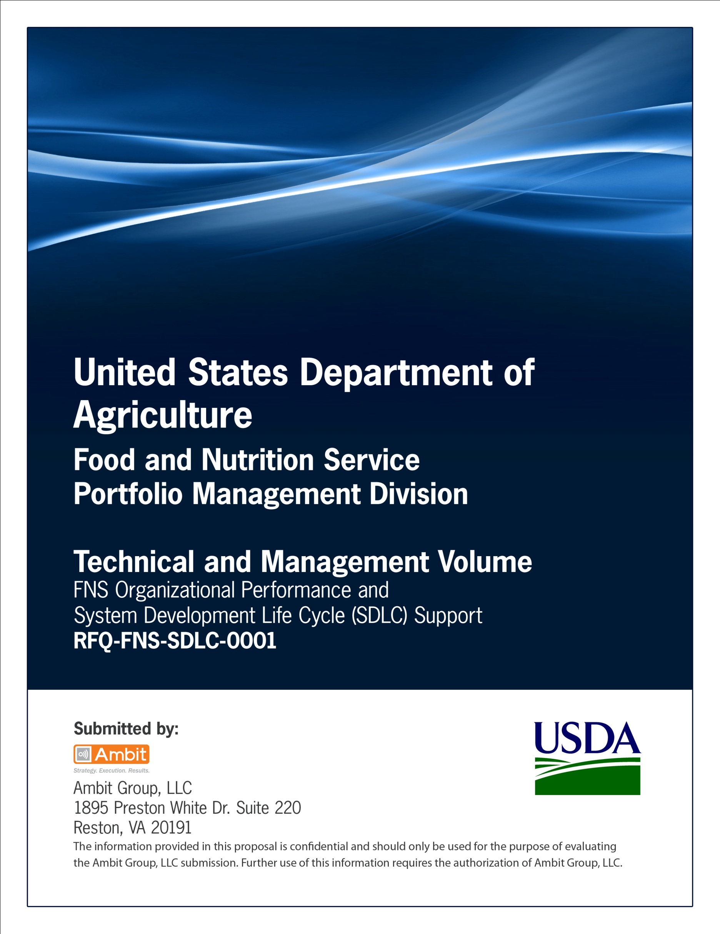

Office of Information Technology
Portfolio Management Division (PMD)

FNS Domain Name Request Template
for
[Project or System Name]

Version 1.1

September 09, 2013

Revision History
Version | Date | Author | Change Description
1.0 | 03-18-2012 | IT Governance Branch (ITGB) | Created the document.
1.1 | 09-09-2013 | IT Governance Branch (ITGB) | Re-formatted the document.
1.2
1.3

Contact Information
Area of Concern | Contact Person
IT Governance Lead | Kevin Russ
SDLC Coordinator | Syed Jaffery
ITIRB Coordinator | Sunny Dilawari
Portfolio Management Division Director, Chief Portfolio Officer | Jacqueline Butler
Program Management Branch Chief | Allison Willcox

Contents
FNS Domain Name Request Template 4
Approvals/Signatures 6

FNS Domain Name Request Template

Only the Chief Information Officer for the Agency/Staff Office may request an usda.gov domain name.

Instructions
Complete this request for a new or changed USDA domain name. All of the questions must be answered completely. Incomplete responses will result in disapproval of the request.

PLEASE NOTE: All requests for domain names will be evaluated for compliance with USDA's Enterprise Architecture. Applications that duplicate the capabilities of existing Enterprise Initiatives will be required to use those capabilities. For example, using userid/passwords falls within the application of USDA’s eAuthentication service.

Request Date: mm/dd/yyyy

Requested Domain Name(s) and Associated IP Address(es)

Domain Name: IP Address
domain-name.agency-abbreviation.usda.gov nnn.nnn.nnn.nn

Host Site (geographic location):

Agency Information:

Agency Name:
Unit(s):
Location:

Administrative Authority Technical Contact
Information Information

Name: Name:
Title: Title:
Email: Email:
Voice: Voice:

This request is for:

( ) a server
( ) an Intranet site
( ) an Internet site
( ) other. Please explain.

Please answer the following questions:

A) Please describe the functions that this domain will support, such as business processes, information delivery or related activities.

B) Who are the target users (for example: citizens, business partners, other Government entities, or employees)?

C) Does this domain require a userid/password? (Y/N) If so, are you using the USDA eAuthentication service for this purpose?

D) Is this domain name part of an IT System? (Y/N) If so,
(1) Is the system in the final stages of Development? Y/N
(2) Has the system been entered in the Enterprise Architecture Repository (EAR)? Y/N
(3) C&A completion date.
(a) If C&A is not completed, will the C&A will be completed (including concurrency review) prior to system implementation? Y/N
(4) Has the system been entered into the Cyber Security Assessment and Management system? (CSAM) Y/N
(5) Has the system been categorized for the FIPS 199 security categorization? Y/N
(6) Has the security plan been completed? Y/N
(7) Identify the IT investment associated with the system:
a) Name (as it appears in CIMR)
b) CIMR ID Number (see your capital planning officer)
(8) Identify the IT acquisition approval (if applicable): Number & Date [contact Efren Valerio or John Rehberger (OCIO)]

E) Has the Privacy Threshold Analysis been completed? Y/N
Does the associated system contain personally identifiable information? (Y/N) If so,
(1) Has a privacy assessment been performed?
(2) Privacy assessment completion date.

F) Does this domain comply with all of the USDA Architectural policies and standards defined in the Directives in the 3600 series? (Y/N)

Review by Agency/Staff Office Chief Information Officer (or designee):
I certify that the answers to the above questions are accurate and complete.
(Signature not required)

Name of Certifying Official:
Title:
Date:

Send domain name requests via e-mail to domain.names@usda.gov.

Approvals/Signatures
The undersigned acknowledge that they have reviewed the [name of document] document and agree with the information presented within this document. Changes to this document will be coordinated with, and approved by, the undersigned, or their designated representatives.
Signature: |  | Date:
Print Name:
Title:
Role: | [Project or System Name] Project Manager
Signature: |  | Date:
Print Name:
Title:
Role: | [Project or System Name] Business Owner
Signature: |  | Date:
Print Name:
Title:
Role: | Organization’s Approving Authority

